*TIME SERIES ANAYSIS AND FORECASTING*

*EX:2*

*AIM:TO IMPLEMENTPROGRAM FROM VISUAIZATION TIME SERIES DATE*

*PROCEDURE:* *To visualize the birth rate over time in a time series, you would typically follow these steps:*

1. ***Gather the Data****: You need historical data that includes birth rates for specific time periods (usually annually). You could source this from databases like the World Bank, government statistics, or health organizations.*
2. ***Prepare the Data****: Make sure the data is in a format that can be easily plotted, with a time column (e.g., years) and a birth rate column (e.g., births per 1,000 people).*
3. ***Choose a Visualization Type****: For time series data, line charts are most commonly used to show trends over time. You can also use other types of visualizations, such as area charts or bar graphs, depending on the context.*
4. ***Plot the Data****: Create the plot, where the x-axis represents the time (e.g., years) and the y-axis represents the birth rate (e.g., number of births per 1,000 people).*
5. ***Analyze Trends****: Look for patterns, trends, or anomalies in the data, such as periods of high or low birth rates, fluctuations, or long-term changes.*

*#data cleaning and loading*  
  
**import** pandas **as** pd  
file_path = r"C:\Users\admin\Downloads\API_SP.DYN.TFRT.IN_DS2_EN_csv_v2_162\API_SP.DYN.TFRT.IN_DS2_EN_csv_v2_162.csv"  
df = pd.read_csv(file_path, delimiter=',', skiprows=4, on_bad_lines='skip')  
df.columns = df.columns.str.replace('"', '').str.strip()  
print("Cleaned Column Names:")  
print(df.columns)

Cleaned Column Names:  
Index(['Country Name', 'Country Code', 'Indicator Name', 'Indicator Code',  
 '1960', '1961', '1962', '1963', '1964', '1965', '1966', '1967', '1968',  
 '1969', '1970', '1971', '1972', '1973', '1974', '1975', '1976', '1977',  
 '1978', '1979', '1980', '1981', '1982', '1983', '1984', '1985', '1986',  
 '1987', '1988', '1989', '1990', '1991', '1992', '1993', '1994', '1995',  
 '1996', '1997', '1998', '1999', '2000', '2001', '2002', '2003', '2004',  
 '2005', '2006', '2007', '2008', '2009', '2010', '2011', '2012', '2013',  
 '2014', '2015', '2016', '2017', '2018', '2019', '2020', '2021', '2022',  
 '2023', 'Unnamed: 68'],  
 dtype='object')

*#Handling & Preprocessing*  
  
df_long = pd.melt(df[['Country Name'] + [str(year) **for** year **in** range(1960, 2024)]],   
 id_vars=["Country Name"], var_name="Year", value_name="Birth Rate")  
df_long['Year'] = pd.to_numeric(df_long['Year'])  
df_long['Birth Rate'] = pd.to_numeric(df_long['Birth Rate'], errors='coerce')  
df_long.dropna(subset=['Birth Rate'], inplace=True)  
print(df_long.head())

Country Name Year Birth Rate  
0 Aruba 1960 4.820000  
1 Africa Eastern and Southern 1960 6.723226  
2 Afghanistan 1960 7.282000  
3 Africa Western and Central 1960 6.459063  
4 Angola 1960 6.708000

*#Visualization (Line plot)*  
df_country = df_long[df_long['Country Name'] == 'India']  
plt.figure(figsize=(10, 6))  
plt.plot(df_country['Year'], df_country['Birth Rate'], marker='o', color='b')  
plt.title('Birth Rate Over Time for India (Line Plot)')  
plt.xlabel('Year')  
plt.ylabel('Birth Rate (per 1000 people)')  
plt.grid(True)  
plt.xticks(rotation=45)  
plt.tight_layout()  
plt.show()

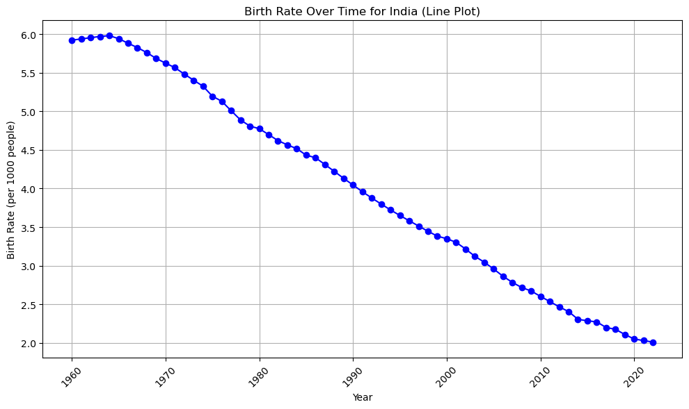

*# Bar plot*  
  
plt.figure(figsize=(10, 6))  
plt.bar(df_country['Year'], df_country['Birth Rate'], color='orange')  
plt.title('Birth Rate Over Time for India (Bar Plot)')  
plt.xlabel('Year')  
plt.ylabel('Birth Rate (per 1000 people)')  
plt.xticks(rotation=45)  
plt.tight_layout()  
plt.show()

*# Box plot*  
*# Histogram (distribution of birth rates)*  
plt.figure(figsize=(10, 6))  
plt.hist(df_country['Birth Rate'], bins=20, color='purple', edgecolor='black')  
plt.title('Distribution of Birth Rate for India (Histogram)')  
plt.xlabel('Birth Rate (per 1000 people)')  
plt.ylabel('Frequency')  
plt.tight_layout()  
plt.show()

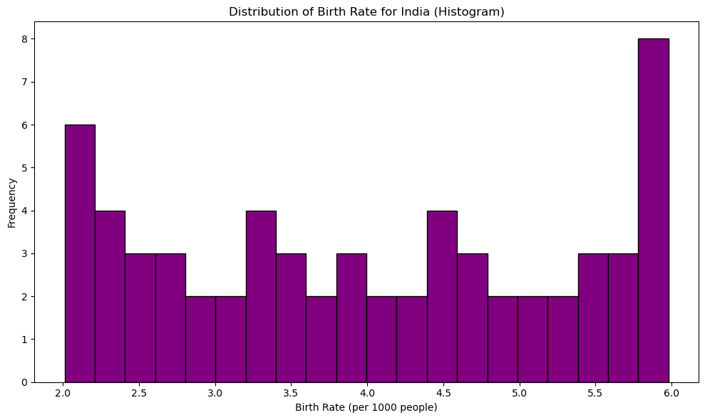

plt.figure(figsize=(10, 6))  
plt.boxplot(df_country['Birth Rate'], vert=False)  
plt.title('Birth Rate Distribution for India (Box Plot)')  
plt.xlabel('Birth Rate (per 1000 people)')  
plt.tight_layout()  
plt.show()

RESULT:THE PROGRAM HAS BEEN SUCESSFULLY EXECUTED

